# Software Safety Assignment # 04

Question 01

init

{

byte i

byte j

do

:: i++

:: j++

od

}

How many different states will have to be analyzed in a simulation performed by SPIN? Give a rational as to how much each variable contributes to your result. (2 points)

Note: If you solve this task with SPIN be cautious about the default search depth, SPIN could abort before it performed an exhaustive simulation.

Answer:

The number of different states that will have to be analyzed in a simulation performed by SPIN is 65536, which is 256×256

This result is because both i and j can be incremented independently from 0 to 255, leading to 256×256 unique combinations or states.

Question 02

[LTL 1](https://moodle.tu-ilmenau.de/mod/assign/view.php?id=49006)

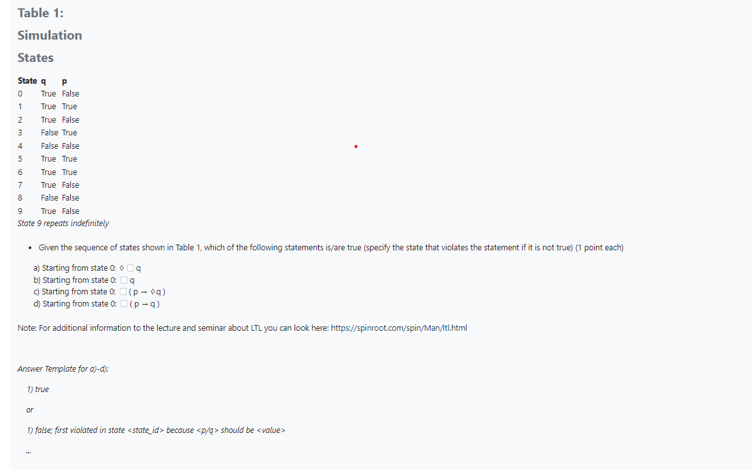

Answer:

a) true

b) false; first violated in state 3 because q should be true

c) true

d) false; first violated in state 3 because q should be true